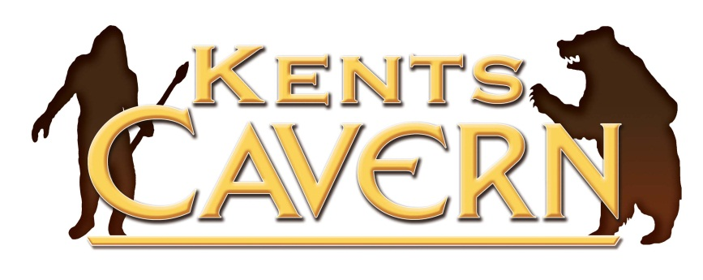

Kents Cavern Ltd, 91 Ilsham Road, Torquay, Devon, TQ1 2JF
Tel: 01803 215136, Fax: 01803 211034

nickpowe@kents-cavern.co.uk www.kents-cavern.co.uk
PRESS RELEASE

Friday, 24th February 2012

KENTS CAVERN GETS TOP
FOOD HYGIENE RATING OF 5
FROM TORBAY COUNCIL’S
FOOD SAFETY TEAM

The restaurant facilities at Kents Cavern were visited last week by two environmental health officers from Torbay Council’s food safety standards team. After a thorough inspection during a busy half-term lunch time service, the inspection team awarded the cavern’s food and beverage operations the top rating of 5.
Nick Powe, owner of the attraction, commented “In the last 5 years we have invested in our restaurant and bar operations to offer visitors and local resident hospitality events all year. While I was confident we’d perform well on any surprise inspection like this, it was very satisfying to gain the top rating.
“We are somewhat eclectic when it comes to catering since we offer such a broad range of hospitality products all year and food and drink has become an important part of our operations. We can find ourselves catering for up to 1500 visitors a day and in the evening, we can be putting on champagne receptions in the cave and waiter-serving 4 course dinners to over 100 guests, dressed up the nines.
“All our staff are very aware of safe food hygiene practices because we train staff to work in all areas of the attraction operations and the restaurant, bar, kiosks and kitchen are hugely important to achieving our overriding objective; to exceed our visitors’ expectations.
“We are delighted to been awarded this top rating of 5 which reflects the hard work of the catering and the senior management team to ensure that everything we do is at the highest standard.”
Torbay Council’s Food Safety team checked how well Kents Cavern is meeting the law by looking at various areas of food and beverage operations. Helen Perkins, Principal Environmental Health Officer at Torbay Council commented:
“We turn up unannounced as we want to see for ourselves how effectively and hygienically the food operation is being run. We look at the condition of the structure of the building, its cleanliness and how hygienically the food is handled. How the business is managed, and documents what it does, in all its food service operations, is key to us evaluating safe food preparation.
“At Kents Cavern we found the procedures and practices adopted by the team met our rating criteria of 5. We made a few recommendations to help them improve what is otherwise an excellent example of an establishment operating safe food practices and hence being awarded our highest rating of 5. To find out what food hygiene rating a food business has you can log onto www.food.gov.uk/ratings
Kents Cavern is open every day and the restaurant has been cleverly designed so that visitors do not have to visitor the caverns to use the restaurant or browse the nicely stocked gift shop. Kents Cavern is available for private hire for club and society dinners, weddings and receptions or for private parties.
The cave received international media exposure at the end of 2011 when an ancient human jawbone from the cave was confirmed to be 42,000 years old making it the oldest human fossil ever found in northwestern Europe and giving the English Riviera Geopark the remarkable world-class claim to fame as the oldest known human settlement in this part of Europe. The story was covered by news agencies around the world and Torquay received over £1million of press exposure as a result of the media coverage over this small human fossil which can be viewed in Torquay Museum.
-ENDS-
NOTES TO EDITOR
- Kents Cavern is a visitor centre for the English Riviera Global Geopark, an international designation supported by UNESCO’s Earth Sciences Division and awarded to areas of outstanding geological interest to encourage the use of geological heritage for the benefit of the local economy.
- For further information on filming or for any other interview or photography requests at Kents Cavern contact Nick Powe at Kents Cavern on (01803) 215136 or e-mail: nickpowe@kents-cavern.co.uk
- The Food Hygiene Standard is managed in Torbay by Torbay Council’s Food and Safety Team who can be contacted on 01803 208025. For more information on the Food Hygiene Rating Scheme visit http://www.food.gov.uk.

