Kents Cavern Prehistoric Caves, Ilsham Road, Torquay, Devon, TQ1 2JF
Tel: 01803 215136 www.kents-cavern.co.uk E-mail: nickpowe@kents-cavern.co.uk
PRESS STATEMENT
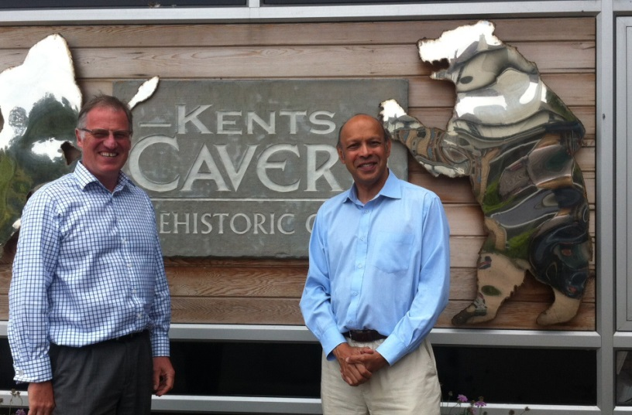
Nick Powe (left) with BBC's Pallab Ghosh at Kents Cavern
Top BBC News reporter walking with a Neanderthal in Kents Cavern seen around the world
Wednesday, 20th August 2014
On tonight’s BBC news bulletins, viewers around the world saw the BBC’s science correspondent, Pallab Ghosh walking through Kents Cavern alongside a Neanderthal reporting on Neanderthal extinction in Europe. The latest research from the University of Oxford, published today in Nature, the world’s leading scientific journal, confirms that Neanderthals and modern humans were both living in Europe for up to 5,400 years, far longer than was previously thought.
Nick Powe, Director of Kents Cavern said: “The paper, by Professor Tom Higham and others, focuses on the continental European evidence. Kents Cavern’s association with humankind goes back a long way and many stone tools discovered here are linked with the Mousterian industry, a tool-making technology attributed to Neanderthals. The paper shows that the Mousterian industry, found across vast areas of Europe and Eurasia, ended between 41,030 to 39,260 years ago.”
“The BBC’s London-based science team wanted to use Kents Cavern having previously filmed a feature on the Kents Cavern jawbone in 2011, when Nature published a paper confirming the fossil to be between 44,200 and 41,500 years old, making it the oldest early modern human fossil in northwestern Europe.
“The BBC news team spent all day here on Monday obtaining a complex sequence of images to show their top science reporter walking through Kents Cavern alongside a Neanderthal. It looked amazing and has gone out across the BBC’s global news networks.”
Professor Tom Higham, who co-authored the Kents Cavern jawbone research, said: “Previous radiocarbon dates have often underestimated the age of samples from sites associated with Neanderthals because the organic matter was contaminated with modern particles. We used ultrafiltration methods, which purify the extracted collagen from bone, to avoid the risk of modern contamination. This means we can say with more confidence that we have finally resolved the timing of the disappearance of our close cousins, the Neanderthals.
Of course the Neanderthals are not completely extinct because some of their genes are in most of us today.”
-ENDS-

NOTES TO EDITOR

More information on the published paper ‘The timing and spatio-temporal patterning of Neanderthal disappearance’, by Thomas Higham et al, published by Nature can be obtained from the University of Oxford News and Information Office on +44 (0)1865 280534 or email: news.office@admin.ox.ac.uk Once live, the link can be found here: http://dx.doi.org/10.1038/nature13621
For further information on filming or for any other interview or photography requests at Kents Cavern contact Nick Powe at Kents Cavern on +44 1803 215136 or email: nickpowe@kents-cavern.co.uk
Professor Thomas Higham is the Deputy Director of the Oxford Radiocarbon Accelerator Unit, Research Laboratory for Archaeology and the History of Art and interim Director of the Advanced Studies Centre at Keble College, Oxford. For his profile, go to http://www.arch.ox.ac.uk/TH1.html
Radiocarbon dating is used for the reliable dating of archaeological material back to around 55 000 years ago. The radioactive isotope of carbon (14C) is formed in the upper atmosphere and later enters the biosphere and is found in all living organisms. When death of an organism occurs, however, no further replenishment of 14C takes place and only decay continues as the remaining 14C decays back to its parent isotope. Scientists know the half-life of radiocarbon (5568 ± 30 yr), which is the time it takes for half of the 14C to decay away. This allows an age to be determined after the abundance of remaining radiocarbon has been measured. Oxford uses accelerator mass spectrometry (or AMS), which makes it possible to directly measure individual 14C atoms. This effectively reduces the weight of material required and makes the measurements much quicker to achieve. AMS can routinely date samples of 1mg carbon or less. For this, around 200-500 mg of bone is needed.
The Kents Cavern jawbone is the oldest early modern human bone found in Britain and on display at the Natural History Museum, London until 28th September in “Britain: 1 Million Years Of The Human Story”. The fossil returns to its home at Torquay Museum afterwards.

