# KENT LOGO caveman_LwRs

English Riviera UNESCO Global Geopark

# Kents Cavern Ltd, Ilsham Road, Torquay, Devon, TQ1 2JF, Tel: 01803 215136 [nickpowe@kents-cavern.co.uk](mailto:nickpowe@kents-cavern.co.uk) [www.kents-cavern.co.uk](http://www.kents-cavern.co.uk)

facebook.com/kentscavern @kents\_cavern

**PRESS STATEMENT**

**New website launched as Torquay’s prehistoric**

**attraction celebrate 113 years**

**Saturday 23rd April 2016**

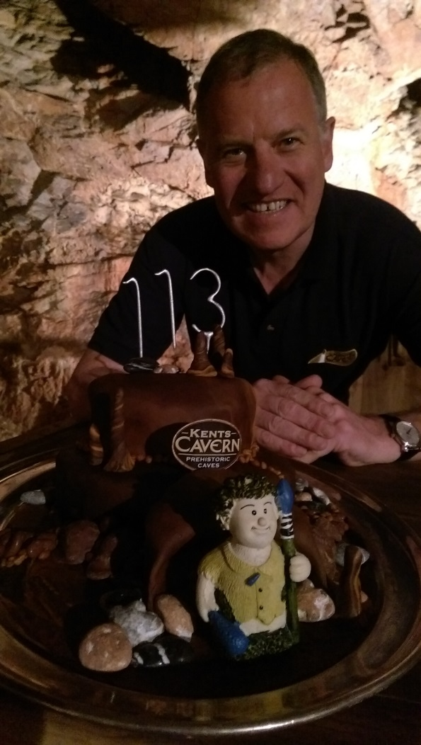

*Pictured in Kents Cavern: Nick Powe with a 113th anniversary cake to mark his great-grandfather becoming custodian of Kents Cavern on the 23 April 1903*

**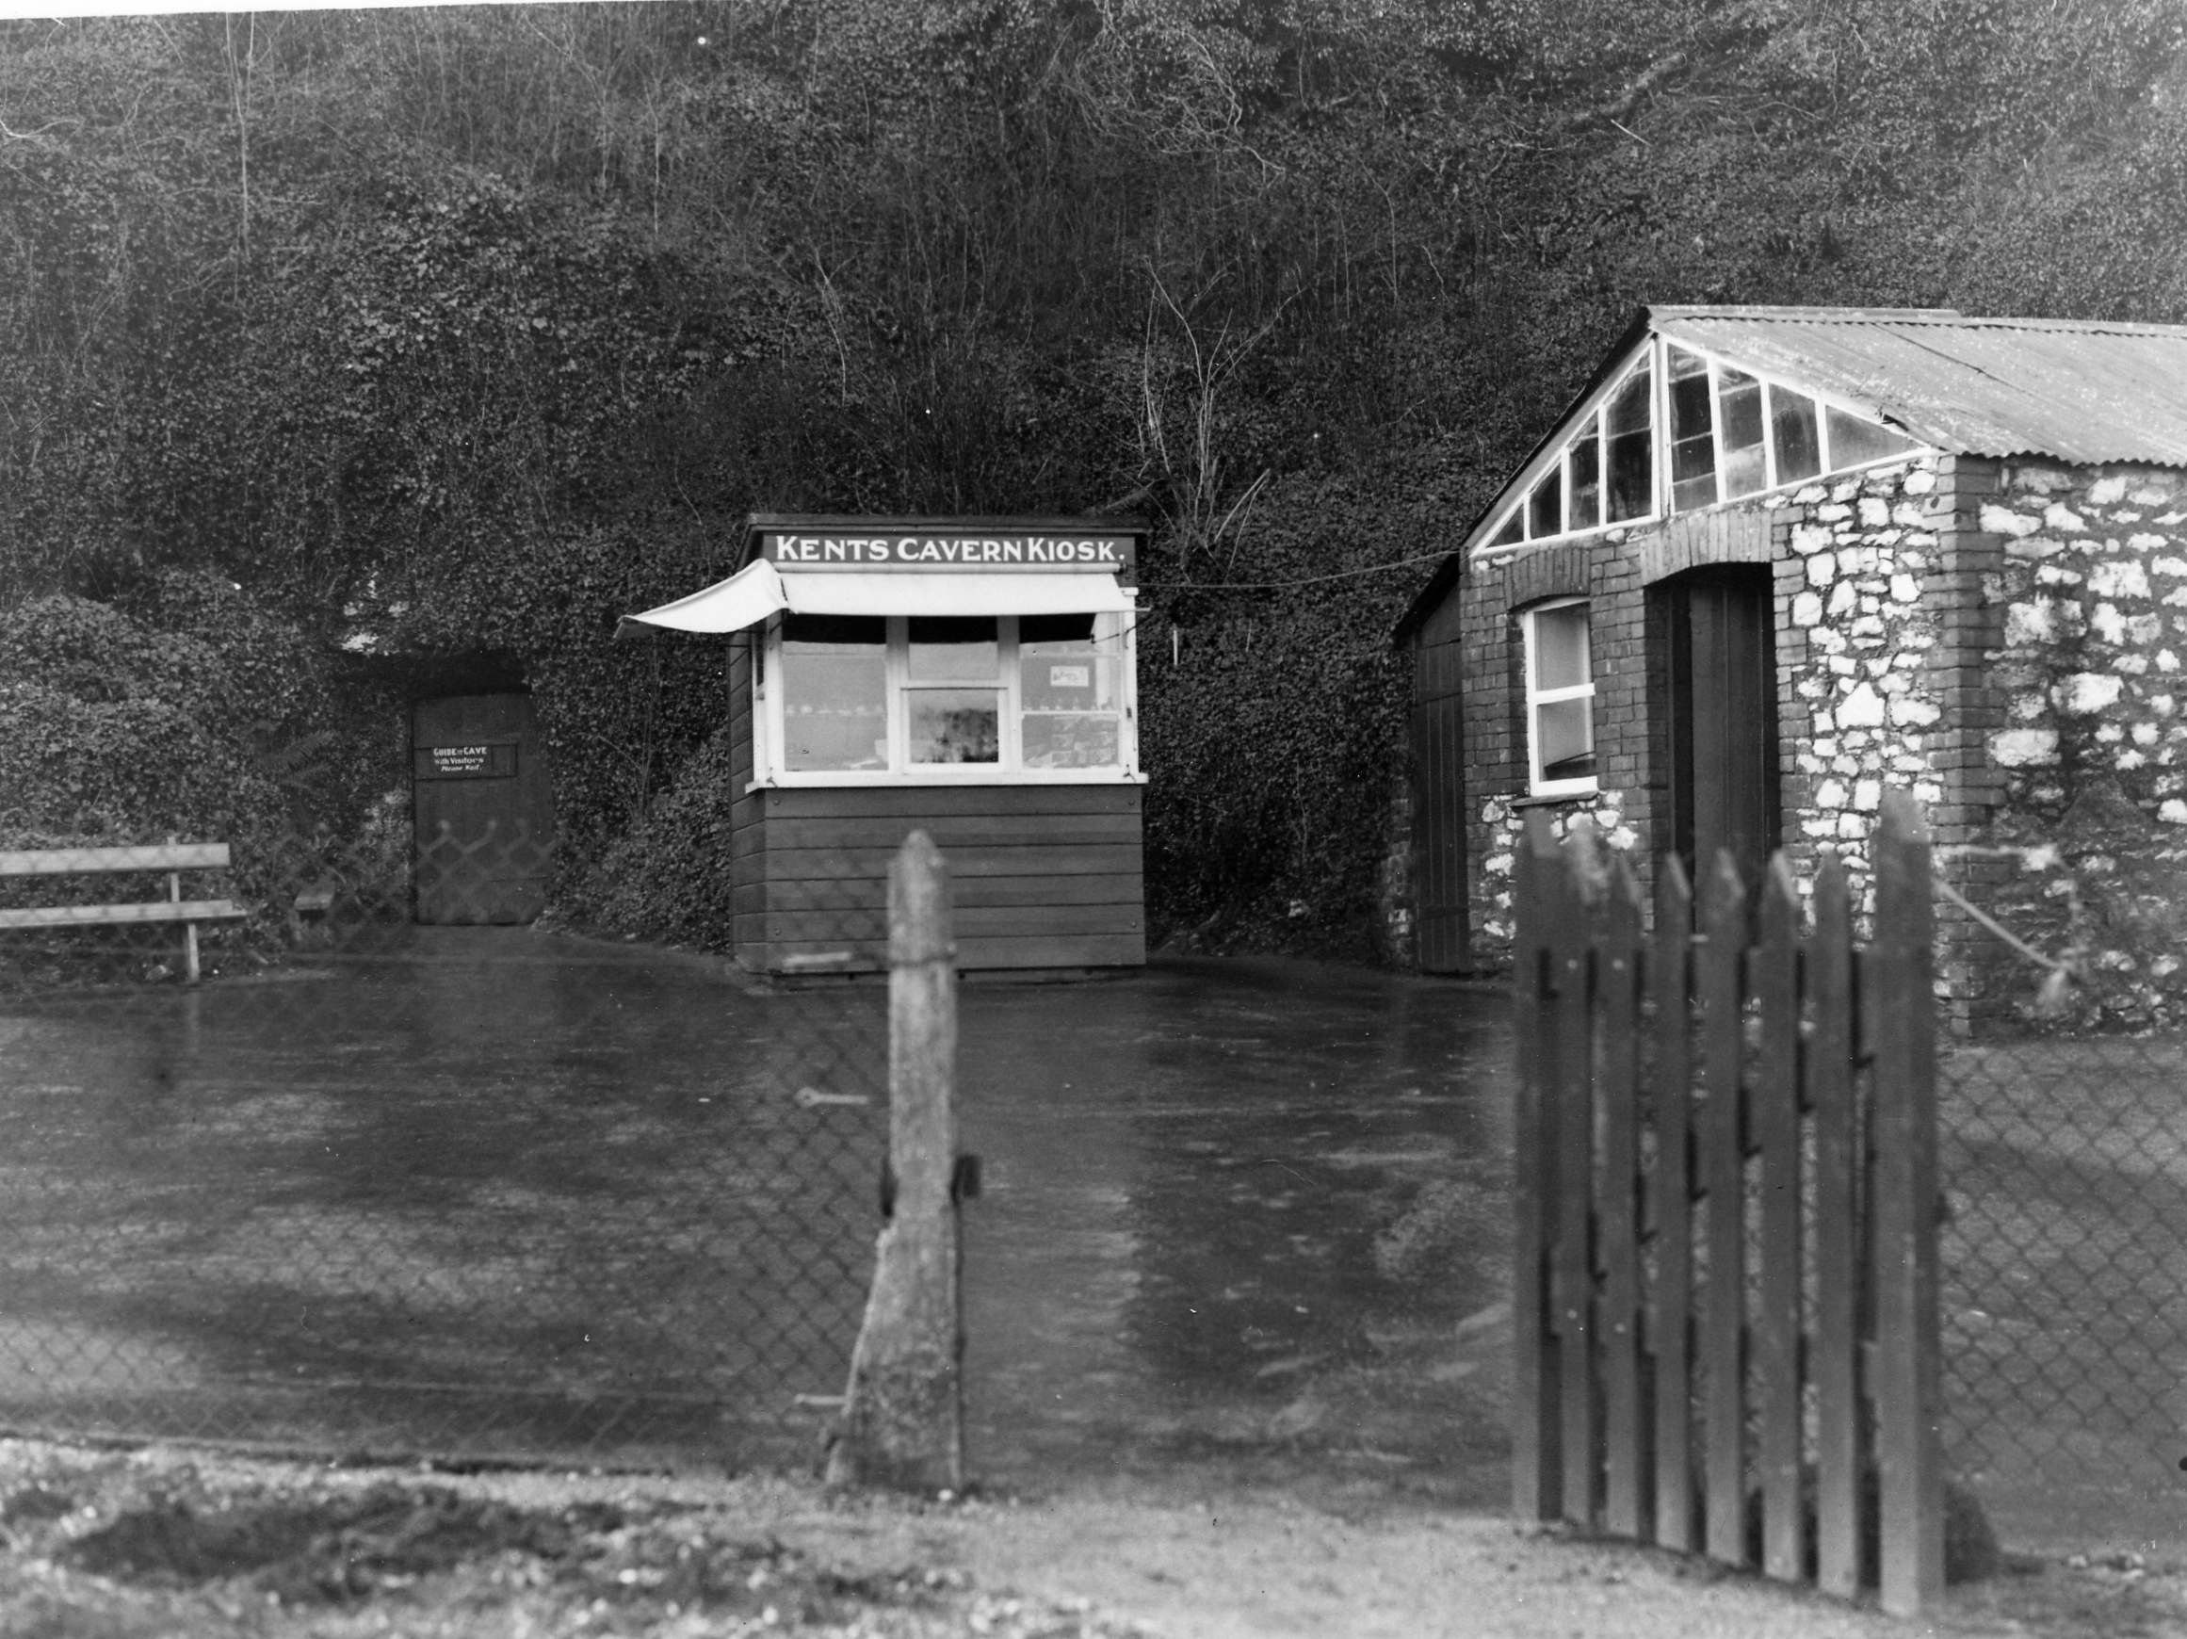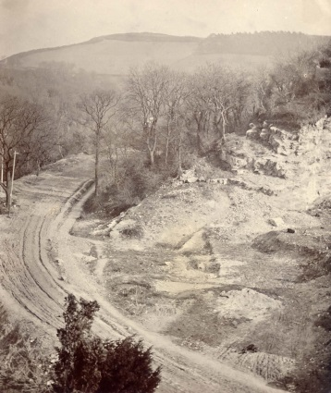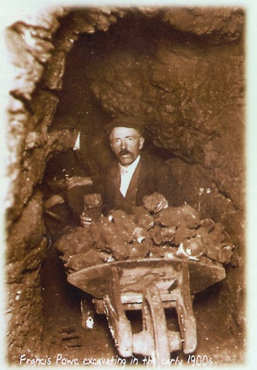**On 23rd April 1903, Francis Powe acquired Kents Cavern, Torquay and 113 years later, the conservation of one of Europe’s most important prehistoric cave sites continues in the hands of his great grandson Nick Powe. Celebrating this achievement the award winning South West attraction has launched a new website at [www.kents-cavern.co.uk](http://www.kents-cavern.co.uk).

Ticket kiosk 1920s

Francis Powe

Kents Cavern 1903

Nick Powe, director of Kents Cavern said: “I am very proud of what my family has achieved over the last 113 years in caring for this exceptional prehistoric cave site.

“The new Kents Cavern website reflects our wider cultural heritage values and our close connection to the UNESCO Global Geopark, giving people more incentive to take a trip to the English Riviera.

“Built into the new website we have some exciting features, in particular “Dig Deeper” which the Kents Cavern Foundation, the charitable body that delivers Stone Age education, scientific research and outreach, has helped develop. We are grateful to the Heritage Lottery Fund for their support for this through Project Firestone. Schools learning about the Stone Age can now download learning resources and we’ve included video footage of the parts of the cavern only accessible with specialist caving equipment. We’ve even developed a map showing where artefacts from Kents Cavern are around the World and this includes some unexpected locations.”

Kents Cavern is firmly in the digital age with a strong social media presence; 6,000 followers on Twitter and close to 2,500 likes on Facebook. The attraction is the 2nd most popular thing to do in Torquay after Babbacombe Model Village and in the top 20 places to go in Devon.

Nick continues: “My great grandfather already had a strong family connection to the cave 113 years ago. His father-in-law, George Smerdon, had been foreman to William Pengelly during the Great Excavation between 1865 and 1880. At the conclusion of this pioneering archaeological endeavour, George became the first cavern custodian. Interest in visiting Kents Cavern grew and Francis began leading cave tours. Visitors included Beatrix Potter, the future King George V as a young prince and Haile Selassie.”

Francis Powe was a carpenter and used the vast underground chambers as a natural workshop for his beach furniture business, supplying boats and bathing huts to the thriving Victorian and Edwardian holiday resort of Torquay. Francis and his son Leslie (Nick’s grandfather) installed paths and electric lighting and created the cave route used today. Leslie handed over the reins to Nick’s father, John and in 2000 Nick became custodian of a cave that *“… holds what are by far the most important known extant Palaeolithic cave deposits in Britain…”*, according to Historic England.

Recently Nick Powe’s Kents Cavern has been instrumental in obtaining UNESCO Global Geopark status for Torbay. In September 2016 more than 800 delegates from over 40 countries from around the World will gather on the English Riviera for the International Conference on UNESCO Global Geoparks, a prestigious event that will bring international attention to Torquay as a tourism destination.

**\_ENDS**

**NOTES TO EDITOR**

* *For further information, including filming or for any other interview or photography requests please contact Nick Powe by e-mail:* [*nickpowe@kents-cavern.co.uk*](mailto:nickpowe@kents-cavern.co.uk)
* ***About Kents Cavern -*** [***www.kents-cavern.co.uk***](http://www.kents-cavern.co.uk)

*Kents Cavern is the most important prehistoric cave sites in Britain open to the public. It has the highest level of state protection as a Scheduled Ancient Monument and is a nature conservation site (SSSI). The cave made international headlines when a human jawbone discovered here was dated at over 41,000 years old, making it the oldest human fossil in northwestern Europe. The Kents Cavern fossil was on display at the Natural History Museum, London in* ***“Britain: 1 million years of the human story”*** *and has now returned to Torquay Museum.*

*Kents Cavern is recognised by UNESCO (United Nations Educational, Scientific and Cultural Organisation) as a key gateway site in the English Riviera UNESCO Global Geopark, a designation awarded to 120 territories in 32 countries across the World with outstanding geology and high cultural heritage value.*

