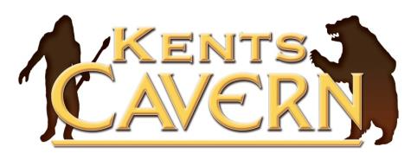

Kents Cavern Ltd, 91 Ilsham Road, Torquay, Devon, TQ1 2JF
Tel: 01803 215136

nickpowe@kents-cavern.co.uk www.kents-cavern.co.uk
PRESS RELEASE
16th March 2013

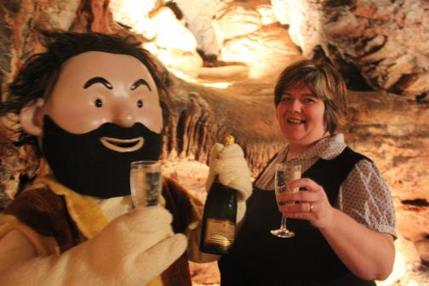
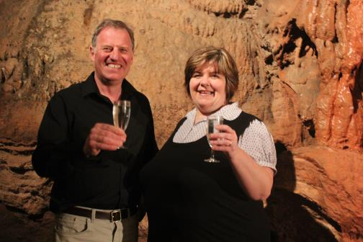

Owner of Kents Cavern Nick Powe with Claire Preece Cavog the Caveman celebrating with Claire Preece
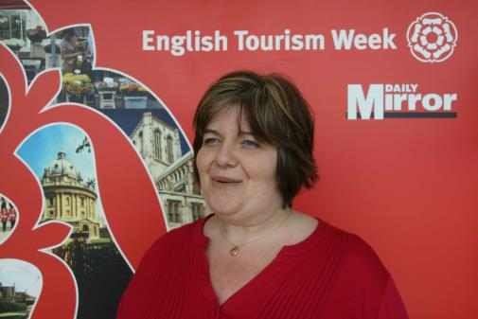
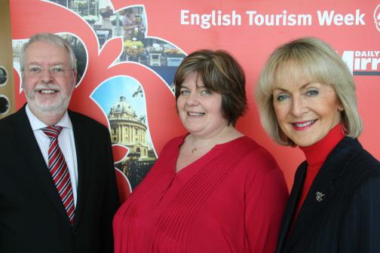

David Curtis-Brignell, Chair of ETW, Claire Preece & Lady Cobham, Chair of VisitEngland Claire Preece
Claire Preece crowned VisitEngland’s
2013 Tourism Superstar

VisitEngland announced today that Claire Preece has been crowned 2013 Tourism Superstar. Claire is Hospitality Manager at Kents Cavern, the award-winning prehistoric cave attraction in Torquay, Devon and visitor centre for the English Riviera Global Geopark.
Claire came top in a public vote run by VisitEngland, the national tourist board in partnership with the Daily Mirror, designed to recognise those unsung heroes who go above and beyond the call of duty to ensure visitors to England have an unforgettable experience. Ten candidates were shortlisted from across the country and the public voted online for the one they thought deserved to be crowned Tourism Superstar 2013.
As Hospitality Manager, Claire is responsible for organising and hosting events at the family-run Kents Cavern, from concerts to guided tours. Claire was nominated for the accolade by Laura Holt from the Devon Tourism Partnership, after scooping the Gold award for Outstanding Customer Service at the Devon Tourism Awards in November 2012. Laura Holt praised Claire’s passion and dedication for tourism and customer experience, as well as her ability to exceed customers’ expectations and deliver the best possible tourism experience, every time.
Commenting on her success, Claire said: “I am absolutely delighted to win this prestigious award. I’d like to thank all the people who voted for me. I love my job here and I work with a dedicated team delivering an outstanding experience, including of course Cavog the Caveman!”

Claire will now be invited to collect her award in person at VisitEngland’s Awards for Excellence held in May this year, where a gathered audience from across the whole of the tourism industry can recognise the contribution frontline staff make to tourism across England.

Lady Cobham, VisitEngland’s Chairman, commented: “Warmest congratulations to Claire - a very worthy winner! Tourism Superstar 2013 was designed to recognise the unsung heroes of the industry, whose unfailing hard work ensures that every visitor to England has a priceless experience. As VisitEngland’s Tourism Superstar 2013, Claire embodies the passion and dedication that abounds in England’s tourism industry. She is an example to others striving to achieve excellence in customer service, and a credit to Kents Cavern.”

Nick Powe owner of the successful cave attraction, said: “We are all delighted for Claire. This is a fantastic achievement and something all the staff here are very proud of. She is certainly a worthy recipient of this national accolade. Of course the award brings a national spotlight on attractions committed to outstanding levels of customer service and Claire’s victory is great news for tourism on the English Riviera and across Devon.”
-Ends-
NOTES TO EDITOR
- For further information, including filming or for any other interview or photography requests with Claire Preece at Kents Cavern contact Nick Powe by e-mail: nickpowe@kents-cavern.co.uk
- Kents Cavern is one of the top ten most important prehistoric caves in Europe.
- Torbay, in South Devon, UK was awarded Global Geopark status, a prestigious designation recognised by UNESCO (United Nations Educational, Scientific and Cultural Organisation), only held by 98 places in the world, where outstanding geological heritage is the driver for social and economic benefit a local community www.europeangeoparks.org. Kents Cavern is a visitor centre for the English Riviera Global Geopark.
- Kents Cavern has been privately owned by the Powe family since 1903.
- The Tourism Superstar Award coincides with start of English Tourism Week (ETW) 16-23 March 2013, an initiative led by the country’s national tourist board VisitEngland and designed to shine a light on the importance of tourism in England. Twitter hash tag is #ETW13.

