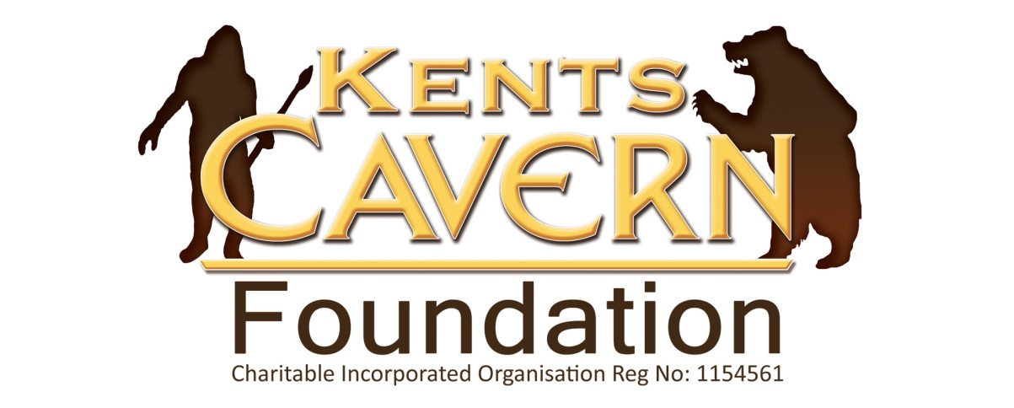

Kents Cavern Prehistoric Caves, Ilsham Road, Torquay, Devon, TQ1 2JF

Tel: 01803 215136 www.kents-cavern.co.uk
nickpowe@kents-cavern.co.uk

PRESS STATEMENT
Thursday 4th September 2014
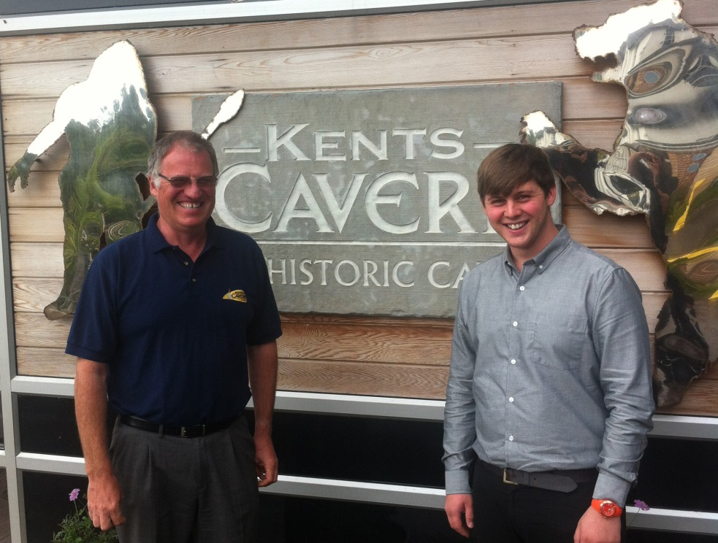
Nick Powe (left) with Elliot Ling, leading Project Firestone
Stone Age for Schools
As schoolchildren across the country begin to be taught Britain’s Stone Age, Torquay’s prehistoric cavern, once home to Neanderthals and Britain’s very first early modern humans, has taken on a new graduate to support schools as they incorporate the Stone Age into the classroom.

In the new National Curriculum, introduced for the first time this week, history for all 7-11 year olds starts with Britain’s Stone Age. Project Firestone, the first significant task of the newly formed Kents Cavern charity, which received support from the Heritage Lottery Fund, is providing support to teachers and schools to integrate the Stone Age into their framework.
The job vacancy to lead Project Firestone at Kents Cavern was advertised nationally and attracted over 50 high-calibre applicants from across the country and Elliot Ling, a graduate from the University of Plymouth, was appointed on 1st September.
Elliot said: “My new role as Education Officer is hugely exciting. Kents Cavern is such a diverse and unique educational resource, with so many links to topics in the new National Curriculum. As one of the most important Stone Age cave sites in Britain, used by Neanderthals and many other Ice Age people, Kents Cavern really is the number one cave site where Britain’s Stone Age history is so tangible. I will also be looking at other topics, including creative writing, art, drama, geography and music, etc..
“I am looking for pilot schools in Devon to work with over the next two years to develop and test enquiry based work programmes that deliver measurable outcomes and benefits. If you are interested in becoming a partner in Project Firestone, please email me at elliotling@kents-cavern.co.uk or via Twitter at @StoneAgeSchool.”
Mayor of Torbay, Gordon Oliver said: “I am delighted to see the oldest dwelling in the country take on its newest recruit, to deliver education and entertainment to young people in Torbay.
“The unique geological asset that is Kents Cavern is not only one of the UK’s favourite attractions – it also provides valuable interpretation about Torbay’s fascinating natural heritage from prehistory to the Victorian age and the present day.
“I wish Elliot every success in the Firestone project, it’s always good to see new jobs created for graduates locally. I urge all Torbay schools to take up this great opportunity to delve into the Stone Age experience with a hands-on approach that will inspire and enthral 7 to 11 year olds.”
Nick Powe, Director of Kents Cavern, said: “We have always attracted primary and secondary school visits but now that the Stone Age is well and truly in the National Curriculum, our education programme needs to link closely to the expectations of schools that follow the national curriculum and those academies that don’t. Project Firestone is all about doing this.
“Kents Cavern’s Ice Age story has international significance. As a gateway site for UNESCO’s English Riviera Global Geopark and with our close relationships with many of the top prehistoric sites across Europe, we are very excited that, thanks to the support from the Heritage Lottery Fund, we will be able to develop, through Project Firestone, some high quality Stone Age experiences that will benefit not just schools but the general public visiting the caverns and generally across Torbay and the key sites in the Geopark.”
ENDS-
NOTES TO EDITOR

For further information on filming or for any other interview or photography requests at Kents Cavern contact Nick Powe at Kents Cavern on +44 1803 215136 or email: nickpowe@kents-cavern.co.uk
The Kents Cavern has been used by Neanderthals and is home of the oldest early modern human bone found in Britain, a 42,000 year old jawbone on display at the Natural History Museum, London “Britain: 1 Million Years Of The Human Story”.

